

**Introduction to Datacenter Automation using Ansible**

**LTRDCN-2920**

**Anis Edavalath**

**Ambili Sasidharan**

Contents

Contents 2

Learning Objectives 4

Network Diagram 5

Task 1.2: Verify installed Ansible version 6

Task 1.3: Create ansible.cfg file 6

Task 1.4: Configure the Ansible Inventory File 7

Task 1.5: Inventory verification 8

Task 1.6: Familiarize Ansible Modules 8

Task 7: Run adhoc commands 9

Module 2: Understanding Ansible Programing Constructs 10

Introducing Debug module 11

Ansible Conditionals 11

Ansible Loops 12

Module 3: Simple Playbooks 13

Task 3.1: Write a playbook to execute show commands 13

Task 3.2 : Using Conditionals 15

Task 3.3: Using Variables 15

Task 3.4 : Using Loops 18

Module 4: Network Operations automation using Ansible 20

Task 4.1: Playbook to back up switches and save at the server 20

Task 4.2 :Create playbook to install SMU package on the switch 21

Step 5: Output verification 23

Task 4.3 : Enable features (OSPF, vPC, lacp) on all routers 24

Module 5: Ansible Roles and Templates 28

Module 6: Heirarchical Playbooks for Nxos configuration using Roles and Templates 30

Task 6.1: Structuring the playbook 30

Task 6.2: Organizing the variables 31

Task 6.3: Create roles for vlans 33

Task 6.4: Create roles for interfaces 33

Task 6.5: Create roles for spanning-tree 34

Task 6.6: Create roles for vpc 35

Task 6.7: Create roles for port channels 36

Task 6.8: Create the main playbook to combine roles 36

Task 6.9: Execute the playbook 37

Module 7: Advanced Ansible features 38

Task 7.1: Encrypt and Decrypt files using ansible vault 38

Task 7.2: Logging Best Practices 39

Task 7.3 Ansible Galaxy 40

Task 7.3.1: Install a role from ansible-galaxy 41

Task 7.3.2: Reuse the role in our playbook 42

Appendix 1: Setting up the env and install Ansible 43

Task 1.1: Installing Ansible on Ubuntu 43

Appendix 2: More Resources 46

Learning Objectives

Upon completion of this lab, you will:

* Have a strong foundational knowledge on Ansible
* Install and replicate Ansible environment in your DC Production and QA environment
* Be able to create basic playbooks for DC automation tasks
* Understand the advanced features provided by Ansible
* Understand the Ansible community resources
* Be able to configure a task orchestration using Ansible

Network Diagram



Lab Access:

Use the handout for lab access details.

Login to the ansible control node using the credentials provided.

Module 1: Setting up and verifying the environment

Ansible has been pre-installed on your controller. You can verify the ansible versions and other ansible command line options in this section. In this module, you will create ansible configuration file and inventory file to customize your set up.

**Objective:** The objective of this module is to verify the pre-installed ansible environment. The required configuration and associated files will be created here. It is recomended to follow the steps exactly as mentioned in this lab guide.

**Ansible Summary:**

Ansible by default manages machines over the SSH protocol.

Ansible only need to install it on one machine (which could easily be a laptop) and it can manage an entire fleet of remote machines from that central point.

## Task 1.2: Verify installed Ansible version

You can verify the version of ansible installed using the command:

root@ltrdcn2029-VM:~ansible –-version

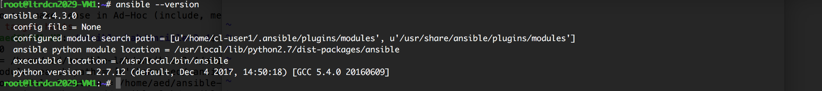

## Task 1.3: Create ansible.cfg file

Ansible config file is the file where you adjust the default settings based on your requirements. This file can be modified any time to customize the environment. You can use any editor of your choice (ex: vi, vim, nano etc..) to create the ‘config’ file.

Step 1: In the root directory open the file ansible.cfg

root@ltrdcn2029-VM:~ vi ansible.cfg

Step 2: Modify the following parameters in the ansible.cfg file. If its already there, just uncomment it by removing ‘#’ or add the lines below.

Inventory = /etc/ansible/hosts

host_key_checking = False

timeout = 10

retry_files_enabled = False

Step 3: Save and close the ansible.cfg file

## Task 1.4: Configure the Ansible Inventory File

Ansible keeps track of all managed devices through a "hosts" file. We need to set up this file first before we can begin to communicate with our Nexus switches.

Ansible can work against multiple systems in your environment . It does this by selecting the portions of the systems listed in your inventory file, which defaults to /etc/ansible/hosts.

Note: For this lab, we will be configuring the hosts file in the working directory.

/home/cl-userxx/

Step 1: Change to working directory and open the file hosts.

nano /home/cl-userxx/hosts

Step 2: Add the host switches that needs to be managed. We are adding the system local host as the first entry in to the inventory file. Please add the following lines to the hosts file.

localhost

[NXOS]

192.168.YYY.1 ansible_user=admin ansible_ssh_pass=nbv12345

192.168.YYY.2 ansible_user=admin ansible_ssh_pass=nbv12345

[ALL:children]

localhost

NXOS

Step 3: Save and close the host file

## Task 1.5: Inventory verification

You can read the contents of inventory file and verify accuracy using the following commands. Give it a try.

$ ansible --list-hosts NXOS

$ ansible --list-hosts ALL

## Task 1.6: Familiarize Ansible Modules

Modules (also referred to as “task plugins” or “library plugins”) are discrete units of code that can be used from the command line or in a playbook task.

To list the installed ansible modules, run the following commands with different options.

$ ansible-doc -l

$ ansible-doc -l | wc -l

$ ansible-doc -l | grep ios

$ ansible-doc -l | grep NXOS

## Task 7: Run adhoc commands

An ad-hoc command is something that you might type in to do something really quick, but don’t want to save for later. Ad-hoc commands can also be used to do quick things that you might not necessarily want to write a full playbook for. Try the following options.

ansible 192.168.YYY.1 -m raw -a "sho ip interface brief"

ansible NXOS -m raw -a "sho ip interface brief"

ansible ALL -m raw -a "sho ip interface brief

Module 2: Understanding Ansible Programing Constructs

[Ansible](https://www.ansible.com/) uses [variables](http://docs.ansible.com/ansible/playbooks_variables.html) to enable more flexibility in playbooks and roles. They can be used to loop through a set of given values, access various information like the hostname of a system and replace certain strings in templates by system specific values. Variables are provided through the playbook itself, inventory file, or by variable files.

But note that variable names have some restrictions in Ansible. Variable names should be letters, numbers, and underscores. Variables should always start with a letter.

Example: var1, var-1

Dictionaries: YAML also supports dictionaries which map keys to values.

|  |
| --- |
| examplevar:  field1: value1  field2: value2 |

A field in the dictionary can be referenced using either bracket notation or dot notation. The below reference will refer to the same value

|  |
| --- |
| examplevar[‘field1’]  examplevar.field1 |

Variable defined in Inventory:

Variables can be defined in the inventory as Group Variables or host Variables.

**[atlanta]**

host1 http_port=80 maxRequestsPerChild=808

host2 http_port=303 maxRequestsPerChild=909

**[atlanta]**

host1

host2

**[atlanta:vars]**

ntp_server=ntp.atlanta.example.com

proxy=proxy.atlanta.example.com

Task 2.1: Write a playbook to create vlan 99 using variables defined in playbook

Step1: Open a playbook vlan.yml using your favorite editor and copy the playbook given below.

---

- name: Configure vlan 99

hosts: NXOS

connection: local

vars:

vlan_id: 99

vlan_name: Ansible_VLAN

tasks:

- name: Configure VLAN ID

nxos_config:

lines:

- vlan {{ vlan_id }}

- name: Configure VLAN Name

nxos_config:

lines:

- name {{ vlan_name }}

parents: vlan {{ vlan_id }}

- name: Show VLAN

nxos_command:

commands: show vlan brief

register: show_vlan

- debug: var=show_vlan.stdout_lines

## Introducing Debug module

This module prints statements during execution and can be useful for debugging variables or expressions without necessarily halting the playbook.

---

- name: Introducing debug module

hosts: localhost

tasks:

- name: Print out something

debug:

msg: Hello world

## Ansible Conditionals

Often the result of a play may depend on the value of a variable, fact (something learned about the remote system), or previous task result. This section covers how conditionals are used in playbooks. Some times, you may want to skip a particular configuration/task on certain hosts based on their existing configuration. For example, you may want to enable ‘OSPF’ routing protocol on all devices if it is not already configured. If OSPF was enabled already on any hosts, you may want to skip the OSPF configuration task on that particular host.

In the next task, we will write a playbook to create vlans 99 on hosts that do not have it already. This is easy to do in Ansible with the ***when*** clause

## Ansible Loops

There are situations when you want to do many things in one task, such as create a lot of users, install a lot of packages, or repeat a polling step until a certain result is reached. Loops allow us to repeat the same action against different states.

Module 2: Simple Playbooks

**Objective:** The objective of this lab is to create the simple paybooks . The playbook will contain tasks to :

Use Raw module to execute commands on the switches

Save the results of the commands in to Variables

Print informational output to the console

**Playbook Description:**The playbook is the basis of ansible automation system. Playbooks can be used to declare configuration variables and orchestrate through the steps of any manual configurations or validations.

* Playbooks are expressed in YAML format.
* Each playbook consists of a list of one or more plays
* Each play consists of one or more tasks
* Each "tasks" section contains a list of modules.
* Each "module" consists a list of actions (~commands).

## Task 3.1: Write a playbook to execute show commands

**Step 1**: Create a directory “module2” inside the root directory and change directory to ‘module2’

mkdir module2

cd module2

**Step 2**: use any editor of your choice to create the file simpleplaybook1.yml

nano simpleplaybook1.yml

**Step 3**: Add the following lines to the simpleplaybook.yml file and save it

---

- name: Run show commands

hosts: NXOS

gather_facts: false

connection: local

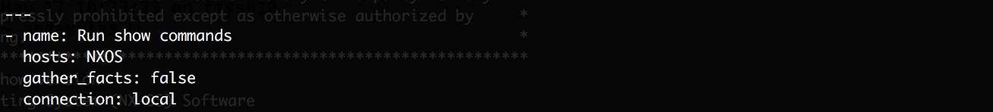

**Create a task to find NXOS version**

**Step 4**: Add the following task to the playbook simpleplaybook1.yml

Note

tasks:

- name: Run show version on nxos switches

nxos_command:

commands: show version

register: version

- name: Print output

debug: var=version.stdout_lines

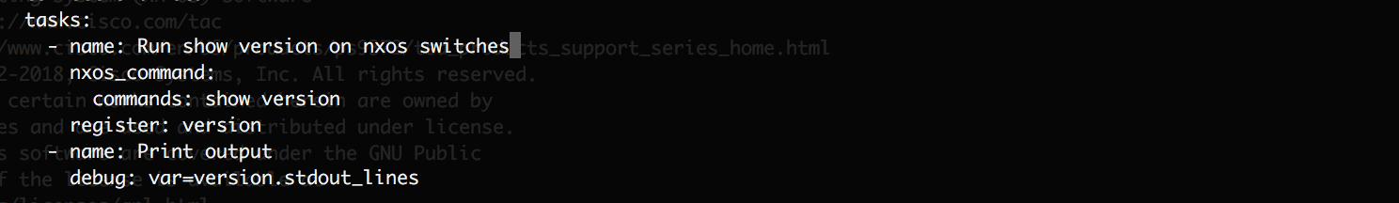

**Execute the playbook**

The playbook syntax can be verified by using the switch **–-syntax check**

**Step 5**: Perform syntax check of the playbook using the command below

ansible-playbook simpleplaybook1.yml –-syntax-check

**Step 6**: Execute the playbook with the following command

ansible-playbook simpleplaybook1.yml

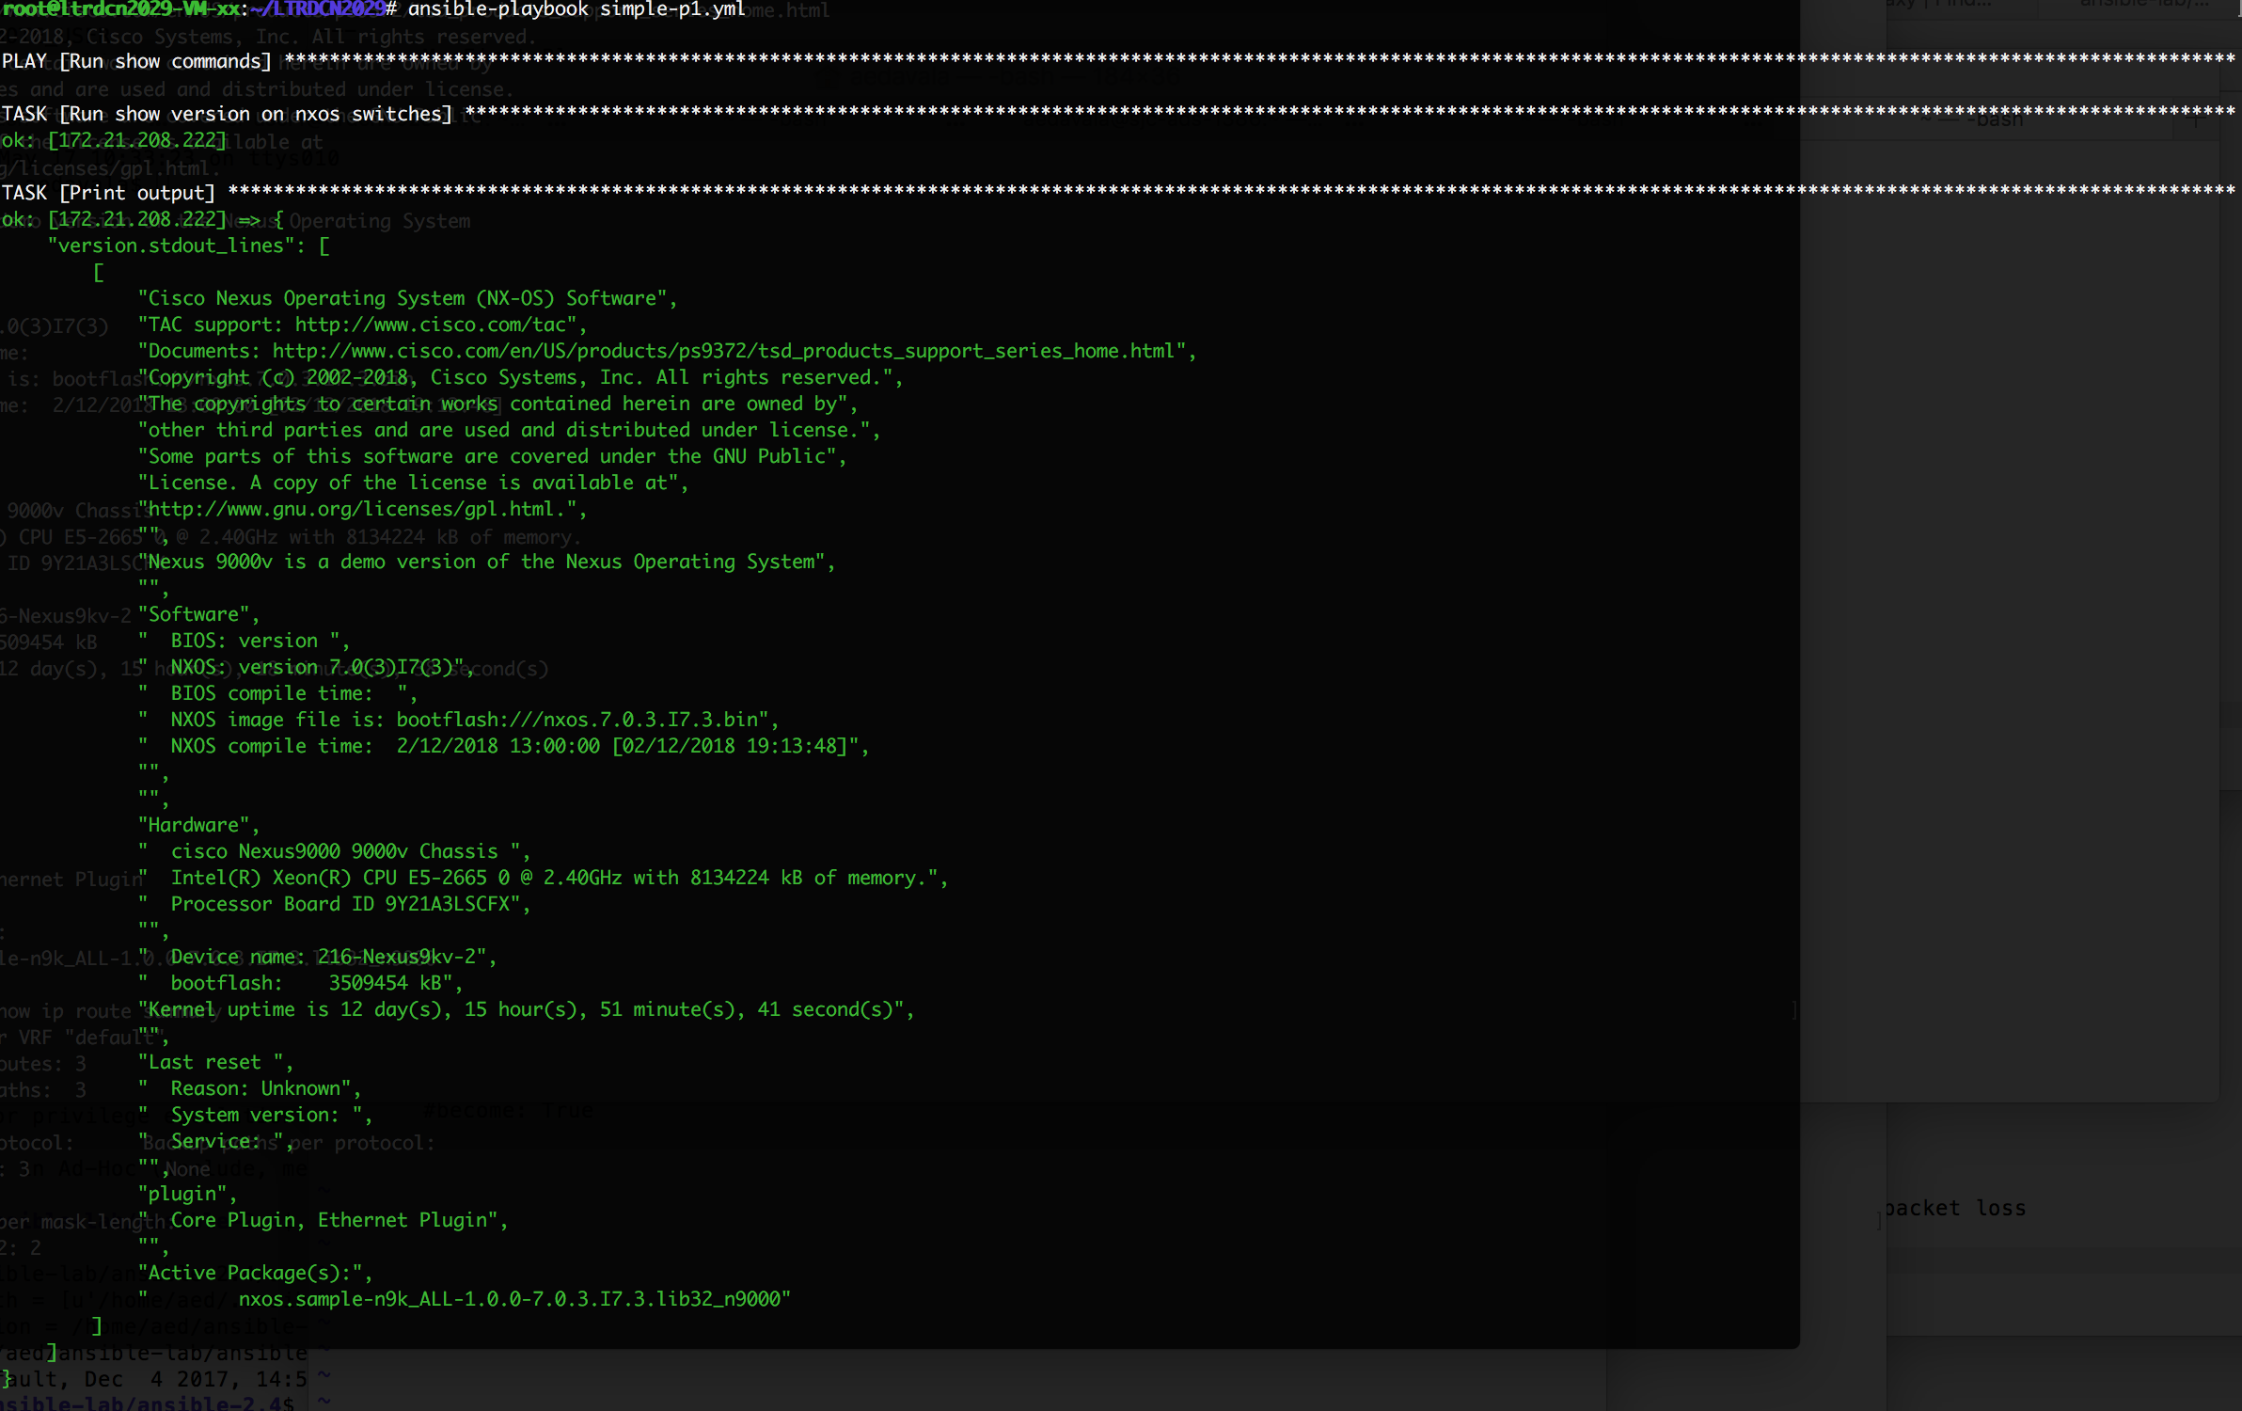

Playbook tasks can be executed step by step by using **–step** switch . We can confirm each task one at a time by using this option

## Task 3.2 : Using Conditionals

**Objective:** The objective of this task is to use the ‘Conditional’ constructs of ansible and find out if the output contains certain string. Here we are searching for the string “NXOS” in the output of show version to determine the type fo the device.

Step 1: **Create task to find the device in a NXOS device**

For this tak we will be using the playbook you created in the previous task.

Add the following lines to the playbook simpleplaybook1.yml

- name: conditional task to verify if switch is an NXOS switch

when: version.stdout | join('') is search('NXOS')

debug: msg="{{inventory_hostname}} is an NXOS Router."



Step 2: Execute the playbook again

ansible-playbook simple-playbook1.yml

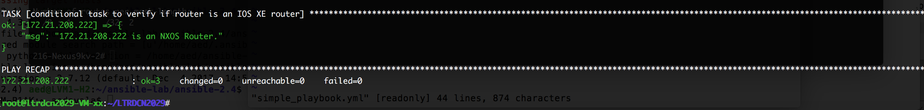

## Task 3.3: Using Variables

**Create playbook to execute show commands with variables**

Step 1: Create a playbook with the name simpleplaybook2.yml and add the following lines in it. Variables can be defined at different locations in Ansible. In this task,we are going to get the output of show interface ethernet1/1 using variables. Note that the variable (interface name) is declared in the playbook and referenced inside the task.

---

- name: variable demo using NXOS routers show commands

hosts: NXOS

gather_facts: false

connection: local

vars:

INTF: Eth1/1

tasks:

- name: read config

nxos_command:

commands:

show run int {{INTF}}

register: INTERFACEoutput

- name: print output

debug: var=INTERFACEoutput.stdout_lines

**Playbook Execution:**

Step 2: Perform syntax check of the play book.

ansible-playbook simpleplaybook2.yml --syntax-check

Step 3: Run the playbook using

ansible-playbook simpleplaybook2.yml

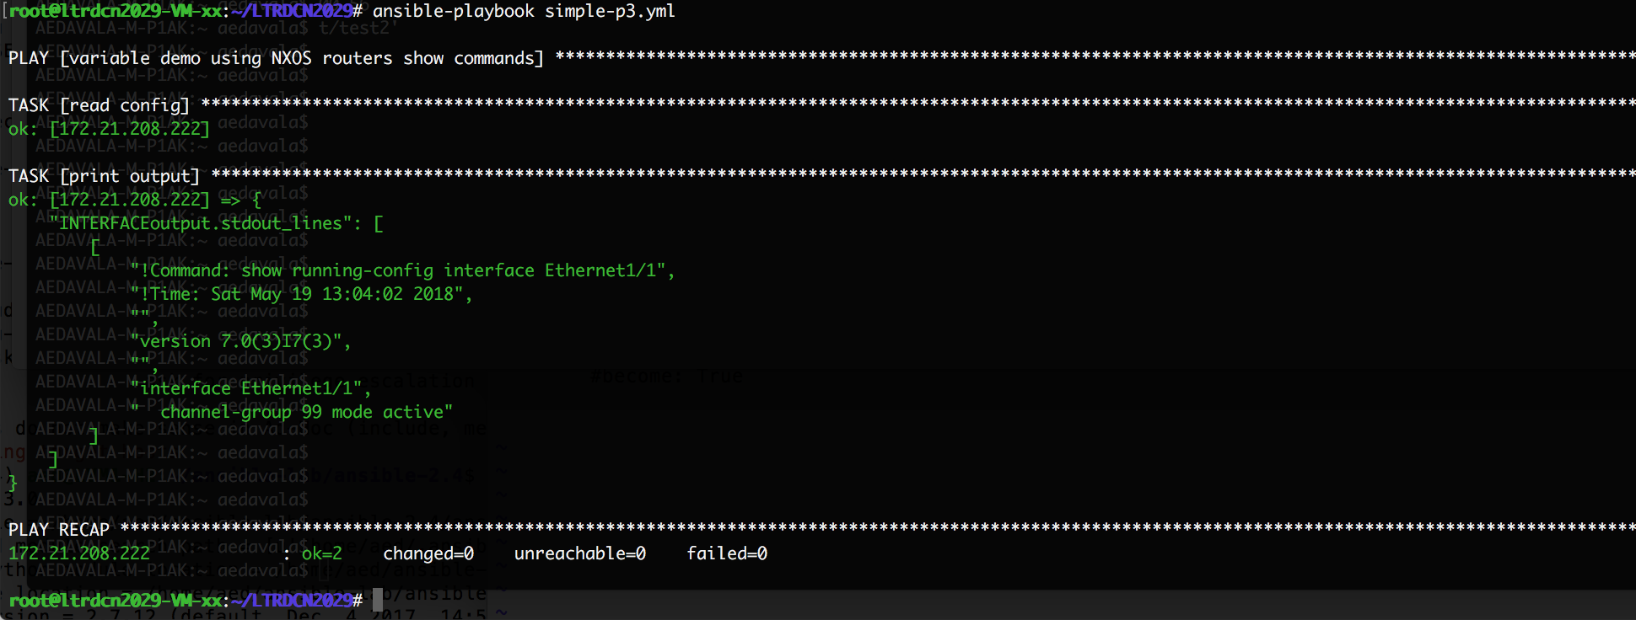

## Task 3.4 : Using Loops

**Create playbook to execute show commands with multiple Items**

Step 1: Create a playbook with the name simpleplaybook3.yml and add the following lines in it . Variables can be defined at different locations in Ansible. In this tak, the variables are declared in the playbook and referenced inside the task.

---

- name: demo loop constructs in Ansible

hosts: NXOS

gather_facts: false

connection: local

tasks:

- name: Collect Router Version and interface brief

nxos_command:

commands: "{{ item }}"

register: LOOPEX

with_items:

- show system resources

- show boot

- show ip int bri

# - debug: var=LOOPEX

**Execute the playbook:**

Step 2: Verify the playbook syntax

ansible-playbook simple-p4.yml –syntax-check

Step 3: Execute the playbook

ansible-playbook simple-p4.yml

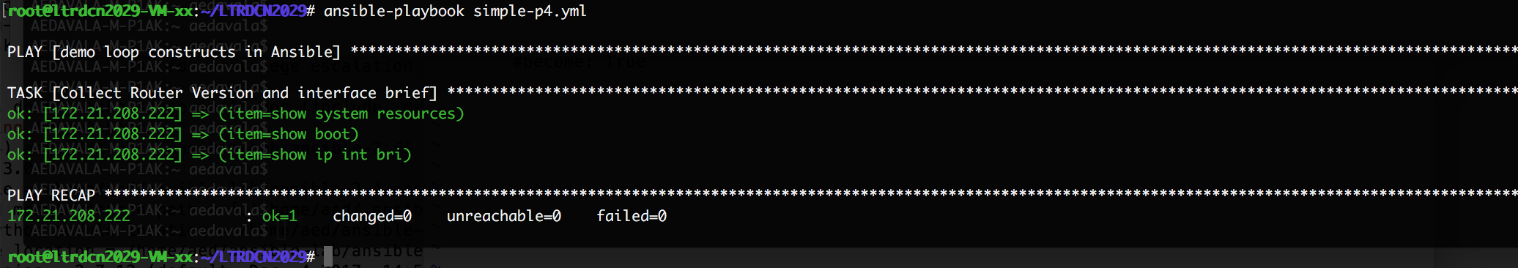

Module 3: Network Operations automation using Ansible

Objective: Objective of this module is to automate few use case scenarios commonly observed in network operations.

## Task 4.1: Playbook to back up switches and save at the server

In this task a playbook is developed to take back up from all the nodes in the inventory and save the backup in a location at the server . Later a cron job can be scheduled to execute this backup script at a specifc time.

Step 1:Create a playbook backup.yml to execute all the commands that is required in the back up configuration. Use loops to iterate through all the required commands

---

- name: Get Router Config and state from All Routers

hosts: NXOS

gather_facts: no

connection: local

tasks:

- name: Collect Show run from all routers

nxos_command:

commands: show run

register: bkp

- debug: var=bkp

Step 2: Edit the previous playbook backup.yml and add the task to generate the variable with the current time value in it. This will be used to name the backup file.

# this line is to set the time to current value

- set_fact: time="{{lookup('pipe','date \"+%Y-%m-%d-%H-%M\"')}}"

Step 3: Edit the playbook and add the task to copy the running config to a destination on the server. Ansible copy module is used here.

NOTE: Please edit the destination location based on your user#.

# this task is using the copy module to copy the file from the nxos device to a server location

- name: save output to /etc/ansible/backups

copy:

content: "{{ bkp.stdout[0] }}"

dest: "/home/cl-user-xx/backups/show_run_{{ inventory_hostname

}}_run_cfg_{{ time }}.txt"

Step 4: Execute the playbook

ansible-playbook backup.yml

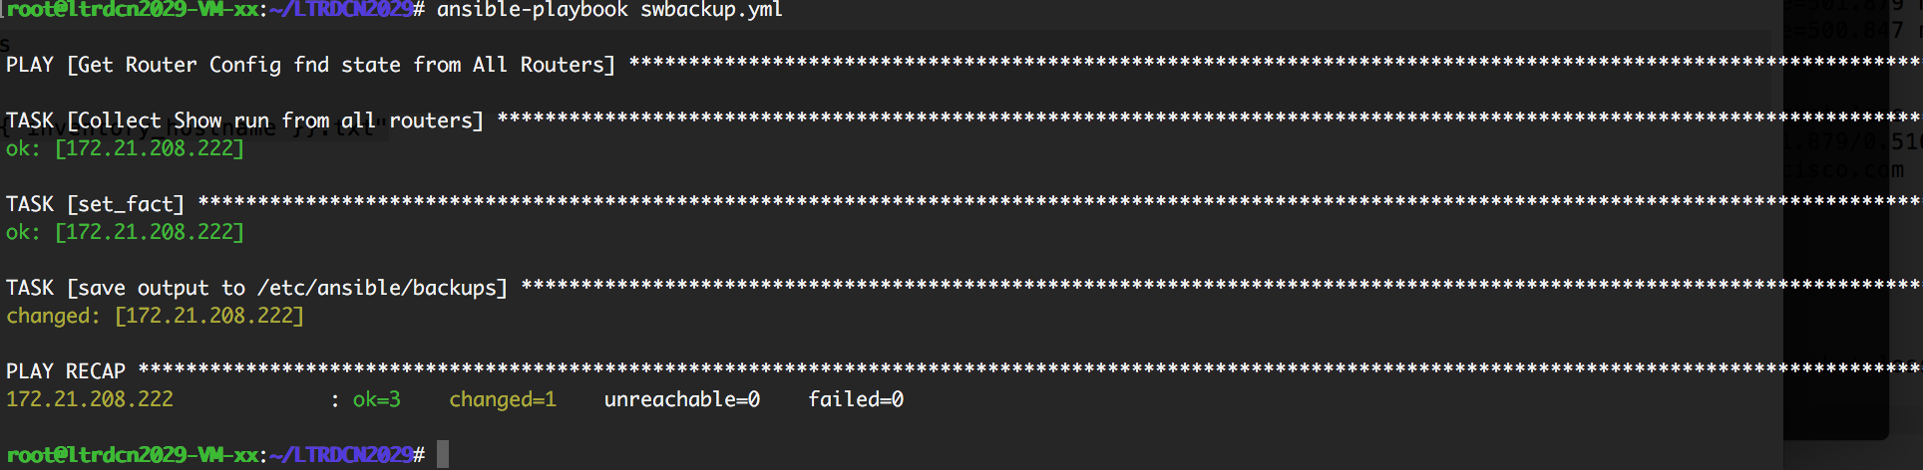

## Task 4.2 :Create playbook to install SMU package on the switch

Objective: Objective of this task is to develop a playbook which can download a SMU package on to all the switches in the inventory and install the pckage on to every switch

SMU: A software maintenance upgrade (SMU) is a package file that contains fixes for a specific defect. SMUs are created to respond to immediate issues and do not include new features. Typically, SMUs do not have a large impact on device operations.

The general procedure for adding and activating SMU packages on the device is as follows:

1. Copy the package file or files to a local storage device or file server.
2. Add the package or packages on the device using the install add command.
3. Activate the package or packages on the device using the install activate command.
4. Commit the current set of packages using the install commit command.

Step 1: Create playbook smu.yml and add the task

---

- name: Copy SMU package from tftp to bootflash

Step 2: Edit the playbook ‘smu.yml’ to add the task to copy the SMU file to the bootflash and perform SMU install

---

- name: Install SMU package on all the devices in the inventory

hosts: NXOS

gather_facts: no

connection: local

tasks:

- name: Install SMU

nxos_smu:

pkg: "nxos.sample-n9k_ALL-1.0.0-7.0.3.I7.3.lib32_n9000.rpm"

**Execute the playbook:**

Step 3: Verify the playbook syntax

ansible-playbook simple-p4.yml –syntax-check

Step 4: Run the playbook

ansible-playbook smu.yml

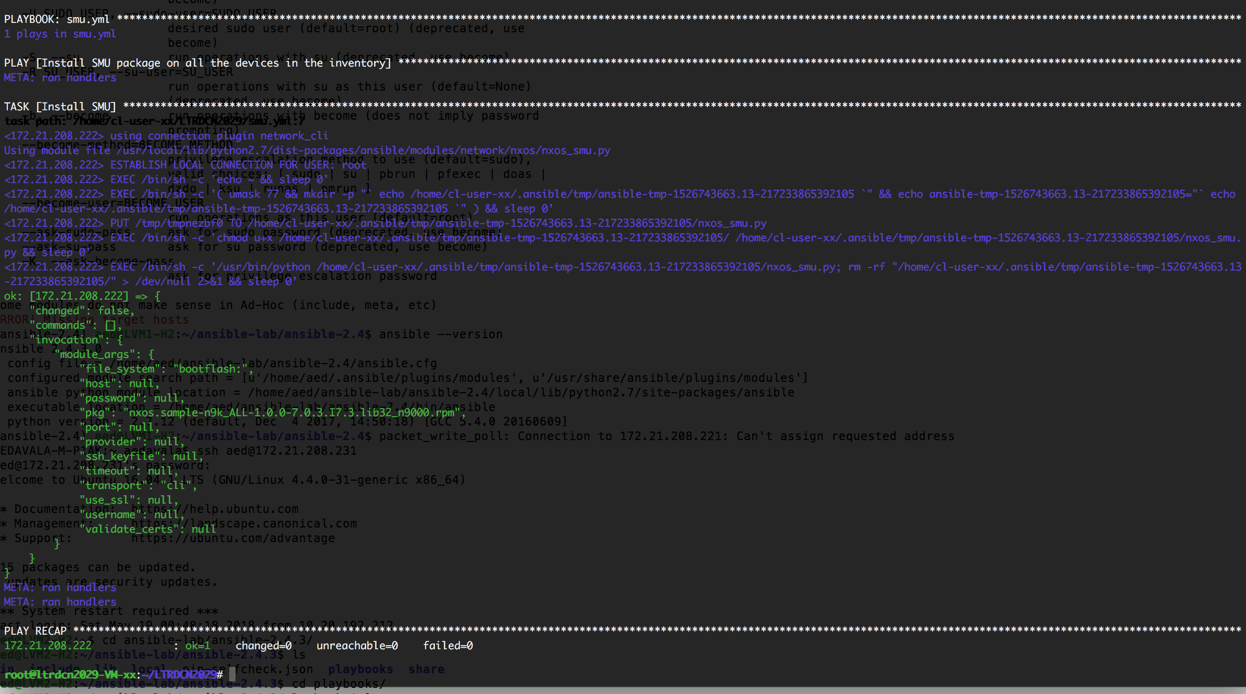

## Step 5: Output verification

Verify the installed package on the nexus 9k switches. For this task, you will have to ssh to one of the leaf switches.

* Show install active
* Show install log

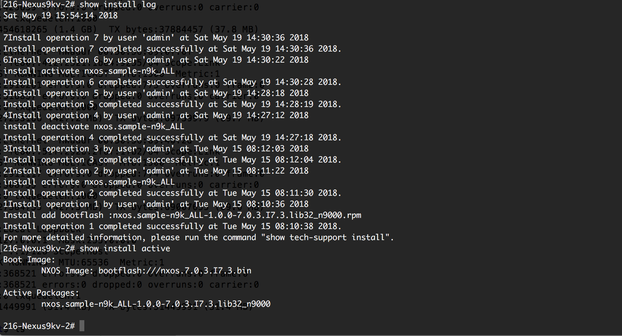

## Task 4.3 : Enable features (OSPF, vPC, lacp) on all routers

**Modules used: nxos_feature or nxos_command**

**4.3.1: Using nxos_feature module**

Any feature can be enabled on the nxos switches using nxos module. Create the following tasks to your playbook –Module5.yml

- name: Ensure lacp is enabled

nxos_feature:

feature: lacp

state: enabled

- name: Ensure ospf is disabled

nxos_feature:

feature: ospf

state: disabled

- name: Ensure vpc is enabled

nxos_feature:

feature: vpc

state: enabled

**4.3.2: Using nxos_command module ( Not suggested)**

The Nxos automation can be performed by using the raw nxos_command module . Though this is not a suggested approach, we can still configure the switch using this method. Special attention need to be paid to the The configuration hierarchy . Create the following task to your playbook module3.yml

- name: fature using command

nxos_command:

commands:

- conf t

- feature lacp

- feature vpc

- feature ospf

**Task 4.3.3: Verify the switch to see the result**

Show run | I feature

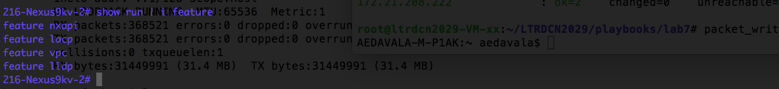

**Task 4.4: Configure Multiline configurations – Global configs**

Objective: utilize nxos_config module to configure multiline configuration lines on nxos devices. We will configure few global parameters on the switch using this module

Task 4.1.1: Create a new playbook spanning-tree-global-pb.yml and paste the following section to it

---

- name: Configure spanning tree global parameters

hosts: NXOS

gather_facts: false

connection: local

tasks:

# tasks file for spanning_tree

- name: Configure global STP Parameters

nxos_config:

lines:

- spanning-tree port type edge default

- spanning-tree port type edge bpduguard default

- spanning-tree port type edge bpdufilter default

**Task 4.4.2 : Execute the playbook:**

ansible-playbook spanning-tree-global-pb.yml -i hosts -k -u admin

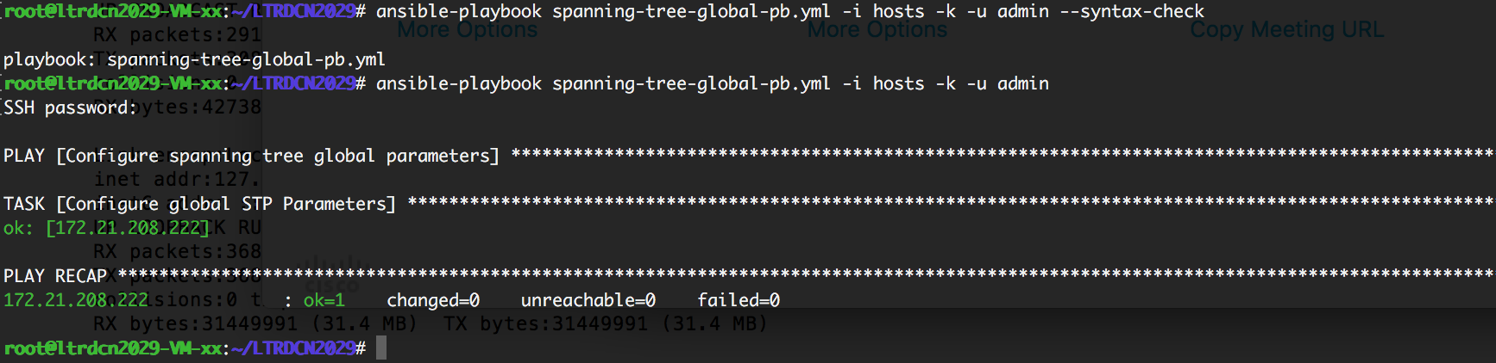

**Task 4.4.2 : verify the configuration on the switch**

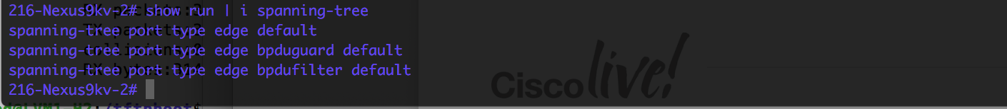

**Task 4.4: Configure Multiline configurations – Access Lists**

Objective: utilize nxos_config module to configure multiline configuration lines on nxos devices. We will configure access control configurations on to the switch using this module

**Task 4.4.1: Create a new playbook acl-pb.yml and paste the following section**

---

- name: Configure access control lines

hosts: NXOS

gather_facts: false

connection: local

tasks:

# tasks file for access list entries

- name: Configure global STP Parameters

nxos_config:

lines:

- 10 permit ip 1.1.1.1/32 any log

- 20 permit ip 2.2.2.2/32 any log

- 30 permit ip 3.3.3.3/32 any log

- 40 permit ip 4.4.4.4/32 any log

- 50 permit ip 5.5.5.5/32 any log

parents: ip access-list test

before: no ip access-list test

match: exact

**Task 4.4.2 : Execute the playbook**

ansible-playbook acl-pb.yml -i hosts -k -u admin

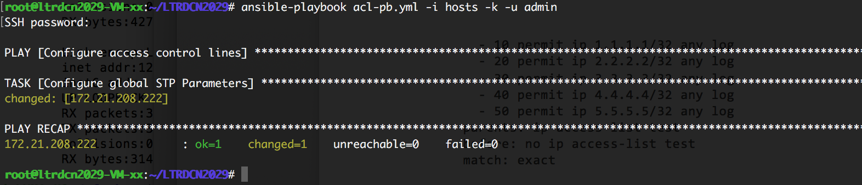

**Task 4.4.3 : Verify the config on the switch**

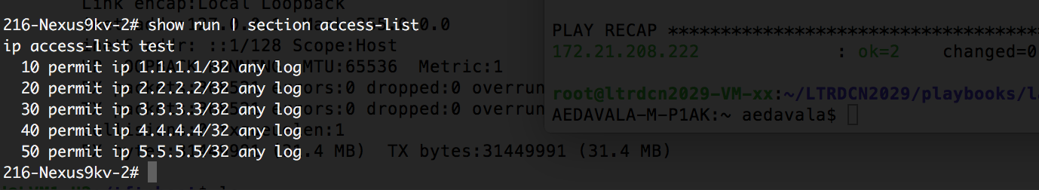

Module 5: Ansible Roles and Templates

Ansible Roles allows you to break up configuration into more modular steps. Roles are a further level of abstraction that will help organize large playbooks into reusable file structures/files. Roles allow you to create very minimal playbooks that then look to a directory structure to determine the actual configuration steps they need to perform.

In order for ansible to correctly handle roles, we need to build a directory structure that it can find and understand. File structures can be created manually or automatically using via ansible CLI- “ansible-galaxy”.

**Objective:** Learn how various components of ansible roles & Jinja2 Templates work together with a simple playbook that uses ansible roles and templates

Module 6: Heirarchical Playbooks for Nxos configuration using Roles and Templates

Configuration commands can be automated using the modules which are already available with ansible. Please refer to the ansible documentation for a list of all available modules for different vendors. In this lab, we will be using different nxos modules to configure different configuration sets using roles.

In this lab we will configure the following using nxos modules

1. Configure vlans
2. Configure uplink ports on interfaces
3. Configure global spaning-tree parameters
4. Configure vpc

## Task 6.1: Structuring the playbook

Perform the following actions to crate the necessary directory structure

# Create a new playbook

cd ~/playbooks

mkdir module5

cd module 5

mkdir roles

cd roles

ansible-galaxy init configure_intfs

ansible-galaxy init create_vlans

ansible-galaxy init enable_nxapi

ansible-galaxy init spanning_tree

ansible-galaxy init vpc

ansible-galaxy init portchannels

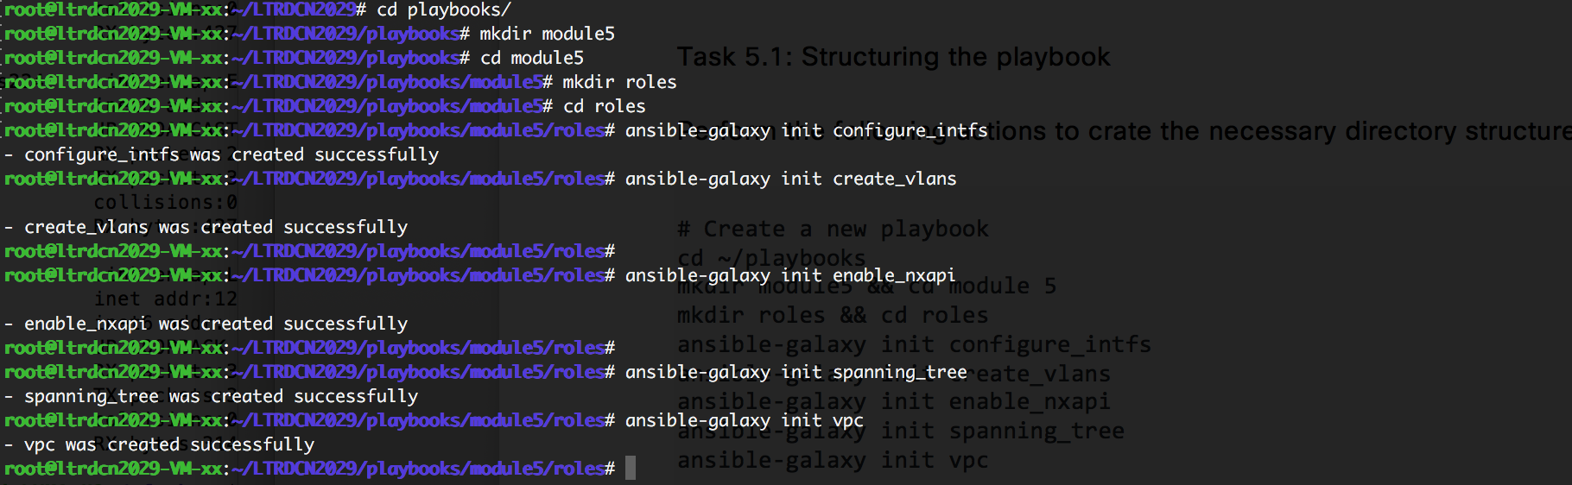

this will create the necessary folder structure required for organizing the playbook. Use the tree command to view the folder structure. If tree is not installed in your machine, install it using **sudo apt-get install tree**

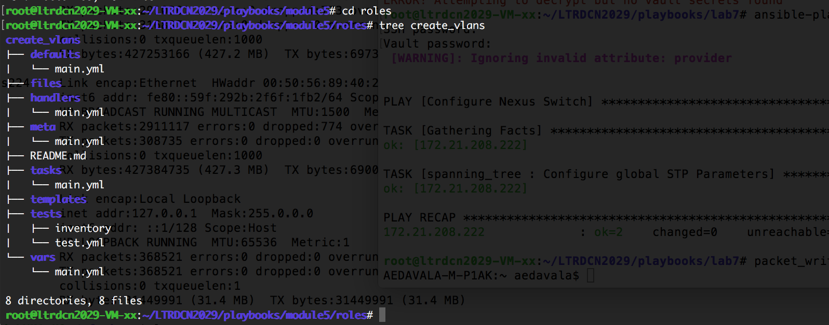

In this lab the connection details are bundled using the ***provider*** parameter, which accepts a dictionary with the connection details.

## Task 6.2: Organizing the variables

Create a file called global_vars in the directory playbooks/module5 and add the following lines to it . Please pay attention to the formatting.

ansible_connection: local

nxos_username: admin

nxos_password: password

con_details:

username: "{{ nxos_username }}"

password: "{{ nxos_password }}"

host: "{{ inventory_hostname }}"

port: 3222

transport: cli

Create a variable file called host_vars and add the following lines to it

vlans:

- id: 10

name: Admin_Vlan

- id: 15

name: Engineering_Vlan

- id: 20

name: Finance_Vlan

- id: 25

name: Marketing_Vlan

- id: 30

name: Sales_Vlan

- id: 99

name: native

- id: 100

name: peer-keepalive

intf_details:

- id: 1/30

description: Thirty

vlan: 10

mode: access

- id: 1/31

description: Thirty_One

vlan: 15

mode: access

- id: 1/32

description: Thirty_Two

vlan: 20

mode: access

- id: 1/33

description: Thirty_Three

vlan: 25

mode: access

- id: 1/34

description: Thirty_Four

vlan: 30

mode: access

- id: 1/35

description: Uplink-1

allowed_vlans: 10,15,20,25,30

mode: trunk

- id: 1/40

description: keepalive

allowed_vlans: 100

native_vlan: 99

mode: trunk

vpc:

domain: 10

systempri: 100

rolepri: 10

pklsrc: 100.100.100.1

pkldst: 100.100.100.2

pklvrf: keepalive

## Task 6.3: Create roles for vlans

cd to the folder ~/playbooks/module5/roles/create_vlans/tasks and open the file main.yml. Add the following lines to that file

# tasks file for configure_vlan

- name: Create VLANs

nxos_vlan:

vlan_id: "{{ item.id }}"

name: "{{ item.name }}"

provider: "{{ con_details }}"

state: present

with_items:

- "{{ vlans }}"

## Task 6.4: Create roles for interfaces

cd to the folder ~/playbooks/module5/roles/configure_intfs/tasks and open the file main.yml. Add the following lines to that file

# tasks file for configure_vlan

- name: Interface - Put Interface into Default

nxos_interface:

interface: Ethernet{{ item.id }}

provider: "{{ con_details }}"

state: default

with_items: "{{ intf_details }}"

when: default_intfs

- name: Interface - Configure Description and L2 mode for Interface

nxos_interface:

interface: Ethernet{{ item.id }}

description: "{{ item.description }}"

mode: layer2

provider: "{{ con_details }}"

state: present

with_items: "{{ intf_details }}"

- name: Interface - Configure as access and assign VLAN

nxos_switchport:

interface: Ethernet{{ item.id }}

mode: access

access_vlan: "{{ item.vlan }}"

provider: "{{ con_details }}"

when: item.mode == "access"

with_items: "{{ intf_details }}"

- name: Interface - Configure as uplink trunk and assign allowed VLANs

nxos_switchport:

interface: Ethernet{{ item.id }}

mode: trunk

trunk_vlans: "{{ item.allowed_vlans }}"

provider: "{{ con_details }}"

when: item.mode == "trunk"

with_items: "{{ intf_details }}"

- name: Interface - Configure L2 for peer keepalive

nxos_switchport:

interface: Ethernet{{ item.id }}

mode: trunk

native_vlans: "{{ item.native_vlan }}"

provider: "{{ con_details }}"

when: item.mode == "trunk"

with_items: "{{ intf_details }}"

## Task 6.5: Create roles for spanning-tree

cd to the folder ~/playbooks/module5/roles/spanning_tree /tasks and open the file main.yml. Add the following lines to that file

# tasks file for spanning_tree

- name: Configure global STP Parameters

nxos_config:

provider: "{{ con_details }}"

lines:

- spanning-tree port type edge default

- spanning-tree port type edge bpduguard default

- spanning-tree port type edge bpdufilter default

- name: Configure network Uplink ports

nxos_config:

provider: "{{ con_details }}"

parents: interface Ethernet{{ item.id }}

lines:

- spanning-tree port type network

with_items: "{{ intf_details }}"

when: item.mode == "trunk"

## Task 6.6: Create roles for vpc

cd to the folder ~/playbooks/module5/roles/vpc/tasks and open the file main.yml. Add the following lines to that file

# task file for configuring vpc

- name: global vpc configuration params

nxos_vpc:

domain={{ item.domain }}

system_priority={{ item.systempri }}

role_priority={{ item.rolepri }}

pkl_src={{ item.pklsrc }}

pkl_dest={{ item.pkldest }}

pkl_vrf={{ item.pkvrf }}

host={{ inventory_hostname }}

provider: "{{ con_details }}"

with_items: vpc

- name: ensure VRF for peer keepalive is created

nxos_vrf:

vrf= {{ item.pkvrf }}

host={{ inventory_hostname }}

provider: "{{ con_details }}"

with_items: vpc

## Task 6.7: Create roles for port channels

cd to the folder ~/playbooks/module5/roles/vpc/tasks and open the file main.yml. Add the following lines to that file

# task file for configuring port channels

- name: portchannel vpc peer link configuration

nxos_vpc_interface:

portchannel=10

peer_link=true

host={{ inventory_hostname }}

provider: "{{ con_details }}"

- name: portchannel vpc configuration

portchannel=11

vpc=11

host={{ inventory_hostname }}

provider: "{{ con_details }}"

## Task 6.8: Create the main playbook to combine roles

cd to the folder ~/playbooks/module5/ and create the file access_vpc.yml. Add the following lines to that file

---

- name: Configure vpc on the datacenter switch

hosts: NXOS

vars_files:

- global_vars.yml

- hosts_vars.yml

roles:

- { role: create_vlans, tags: [ "vlans" ] }

- { role: configure_intfs, tags: [ "intfs" ] }

- { role: spanning_tree, tags: [ "stp" ] }

- { role: vpc, tags: [ "vpc" ] }

- { role: configure_portchannels, tags: [ "portchannels" ] }

## Task 6.9: Execute the playbook

Ansible-playbook access_vpc.yml –i hosts -u admin –k -vvvv

Module 7: Advanced Ansible features

**Objective** : Familiarize with the additional advanced features available in Ansible including security features and the best practices in using them while automating with Ansible. Ansible Vault , logging best practices, Ansible, Galaxy and error handling will be covered in this module.

**Ansiblle Vault:** Ansible Vault is a feature of ansible that allows you to keep sensitive data such as passwords or keys in encrypted files, rather than as plaintext in playbooks or roles. The encrypted vault files can then deistributed in a source control system.

Ansible Vault can encrypt any structured data file . The include Group Vars, Host Vars, Inventory, GlobalVars, variables loaded by “include vars” or vars_files, Role variables and Role Defaults. Similarly, Ansible tasks and Handlers can also be encrypted.

## Task 7.1: Encrypt and Decrypt files using ansible vault

**Encrypt the global vars file using Vault:**

Execute the following command

ansible-vault encrypt global_vars.yml

New Vault password:

Confirm New Vault password:

Encryption successful



Similarly to decrypt the file, use the switch –decrypt with above command



**Executing the playbook with encrypted global vars file**

**E**xecute the playbook with the switch *–-ask-vault-pass* command

Ansible-playbook playbook.yml –i hosts –ask-vault-pass

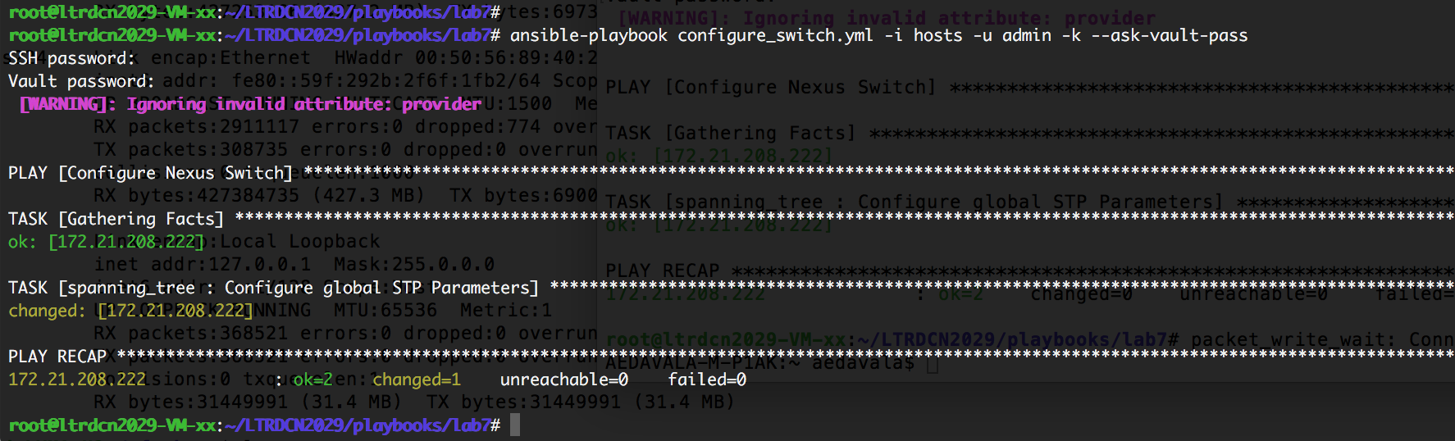

Verify the encrypted file

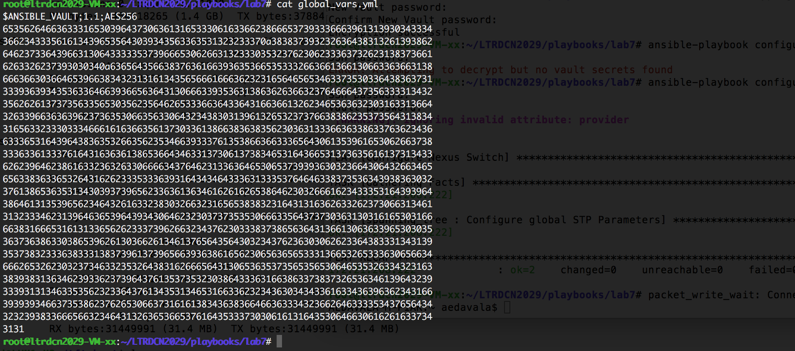

## Task 7.2: Logging Best Practices

Ansible improved logging to help diagnose and troubleshoot issues regarding Ansible Networking modules. Logging is disabled by default and it can be enabled via ANSIBLE_LOG_PATH and ANSIBLE_DEBUG options.

# Specify the location for the log file

export ANSIBLE_LOG_PATH=~/ansible.log

# Enable Debug

export ANSIBLE_DEBUG=True

# Run with 4*v for connection level verbosity

ansible-playbook -vvvv ...

After Ansible finished running , you can inspect the logs to check for any troubleshooting

**Log Snippet:**

2018-05-20 11:27:59,758 p=21711 u=root | PLAY [Configure Nexus Switch] ************************************************************************************************************

2018-05-20 11:27:59,771 p=21711 u=root | TASK [Gathering Facts] *******************************************************************************************************************

2018-05-20 11:28:00,615 p=21711 u=root | ok: [172.21.208.222]

2018-05-20 11:28:00,626 p=21711 u=root | TASK [spanning_tree : Configure global STP Parameters] ***********************************************************************************

2018-05-20 11:28:01,515 p=21765 u=root | creating new control socket for host 172.21.208.222:22 as user None

2018-05-20 11:28:01,516 p=21765 u=root | control socket path is /home/cl-user-xx/.ansible/pc/5d868b76d7

2018-05-20 11:28:01,516 p=21765 u=root | current working directory is /home/cl-user-xx/LTRDCN2029/playbooks/lab7

2018-05-20 11:28:01,516 p=21765 u=root | using connection plugin network_cli

2018-05-20 11:28:01,565 paramiko.transport starting thread (client mode): 0xb768ffd0L

2018-05-20 11:28:01,566 paramiko.transport Local version/idstring: SSH-2.0-paramiko_2.4.1

*p=21765 is the Process ID (PID) for ansible connection process*

*u=root is the user running ansible. Not the remote-user attempting to connect to device*

## Task 7.3 Ansible Galaxy

[Galaxy](https://galaxy.ansible.com/), is a free site for finding, downloading, and sharing community developed roles. Downloading roles from Galaxy is a great way to jumpstart your automation projects.

You can also use the site to share roles that you create. By authenticating with the site using your GitHub account, you’re able to *import* roles, making them available to the Ansible community. Imported roles become available in the Galaxy search index and visible on the site, allowing users to discover and download them.

Ansible’s official community for sharing the roles developed by users.

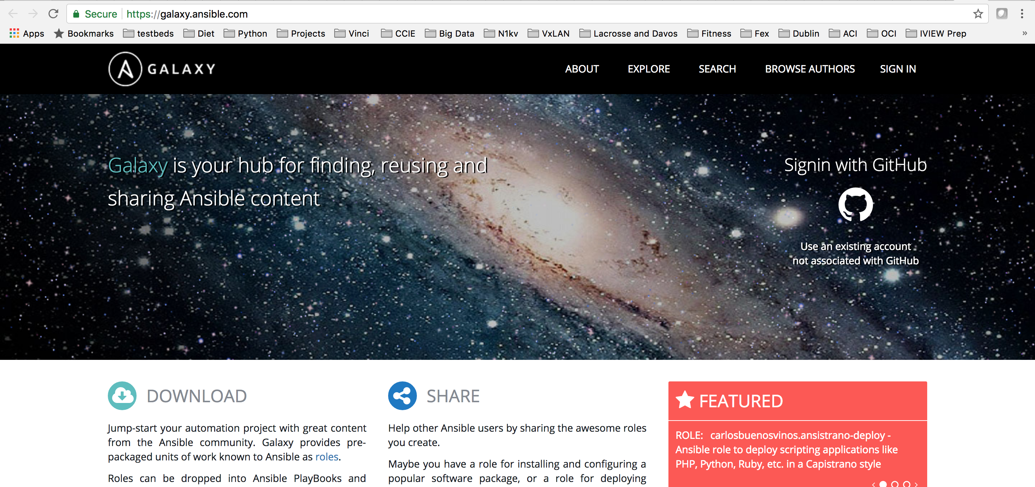

## Task 7.3.1: Install a role from ansible-galaxy

ansible-galaxy install robertwatson3.nxos_prepare

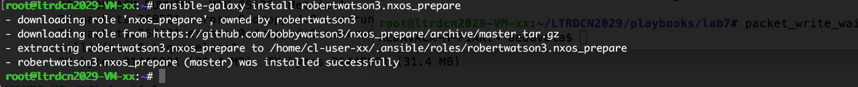

The files will be downloaded in to the hidden folder in your home directory

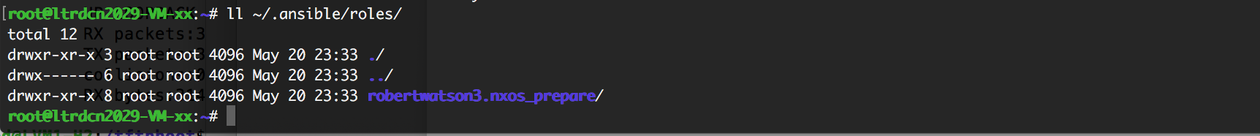

## Task 7.3.2: Reuse the role in our playbook

Create a playbook galaxy-pb.yml and add the following lines to it

---

- hosts: nxos

connection: local

gather_facts: yes

force_handlers: True

vars:

config_backup_path: "bootflash:/configs/config_backup.cfg"

backup: True

disable_nxapi: False

vars_prompt:

- name: switch_username

prompt: "What is the switch username?"

private: False

- name: switch_password

prompt: "What is the switch password?"

roles:

- nxos_prepare

Appendix 1: Setting up the env and install Ansible

**Objective:** The objective of this module is to install Ansible controller in Ubuntu linux VM. The required configuration and associated files will be created here. It is recomended to follow the steps exactly as mentioned in this lab guide.

**Ansible Summary:**

Ansible by default manages machines over the SSH protocol.

Ansible only need to install it on one machine (which could easily be a laptop) and it can manage an entire fleet of remote machines from that central point.

[**Control Machine Requirements**](https://docs.ansible.com/ansible/2.3/intro_installation.html#id13)**:**

Currently Ansible can be run from any machine with Python 2.6 or 2.7 installed (Windows isn’t supported for the control machine).

## Task 1.1: Installing Ansible on Ubuntu

Step 1: Open the SSH client and login to your assigned control VM with the provided credentials. Elevate to sudo privilege.

cl-userx-host:~ ssh [cl-userx@172.21.208.ABC](mailto:cl-userx@172.21.208.ABC)

[cl-userx@172.21.208.ABC’s](mailto:cl-userx@172.21.208.ABC's) password:

cl-userx @ltrdcn2029-VM:~ sudo –s

[sudo] password for cl-userx:

root@ltrdcn2029-VM:~

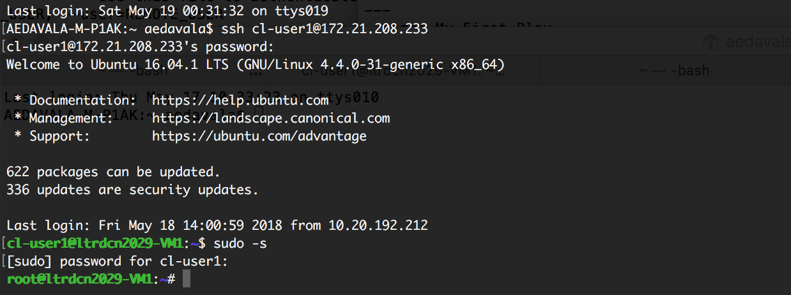

Step 2: Install the packages

root@ltrdcn2029-VM:~sudo apt-get update

root@ltrdcn2029-VM:~sudo apt-get install python-pip

root@ltrdcn2029-VM:~sudo pip install ‘ansible == 2.4.3.0’



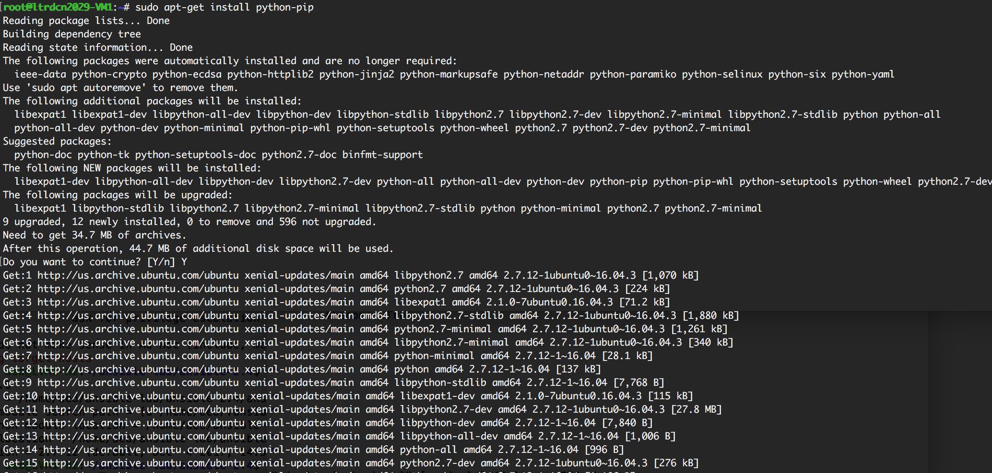

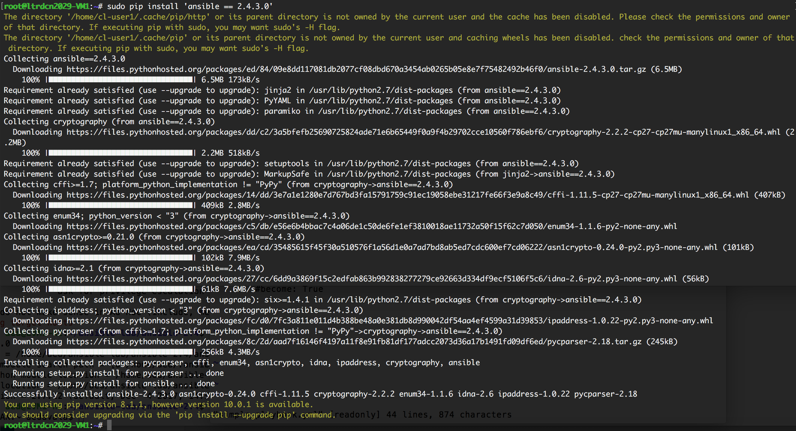

Appendix 2: More Resources

[Ansible Doumentation](http://docs.ansible.com/)

[Ansible Galaxy official community](https://galaxy.ansible.com/)